

Figure 1 : Interface of Login Page



Figure 2 : Interface of Register New Account

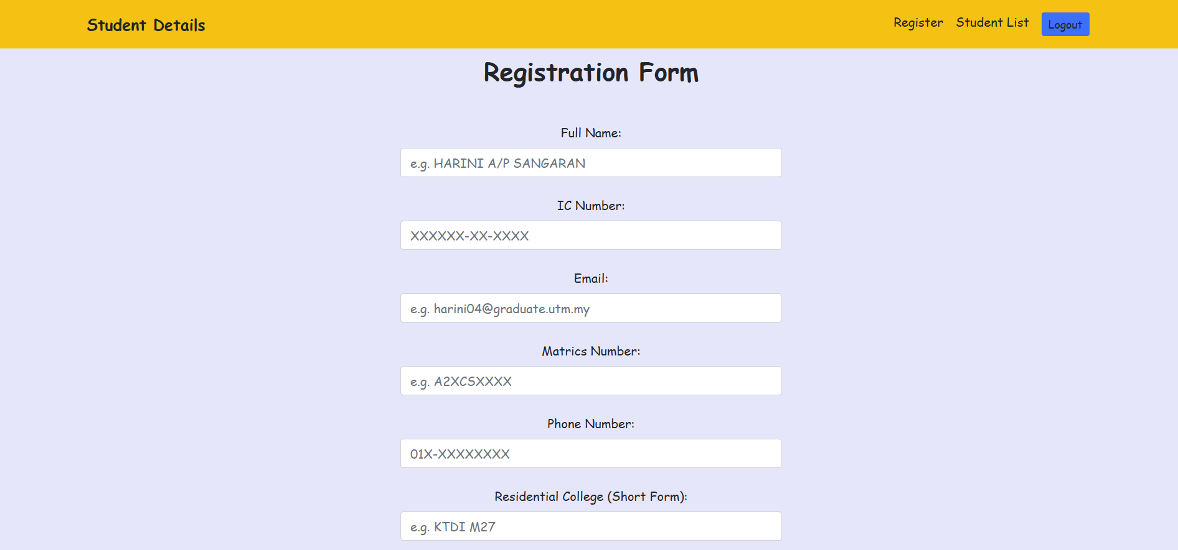

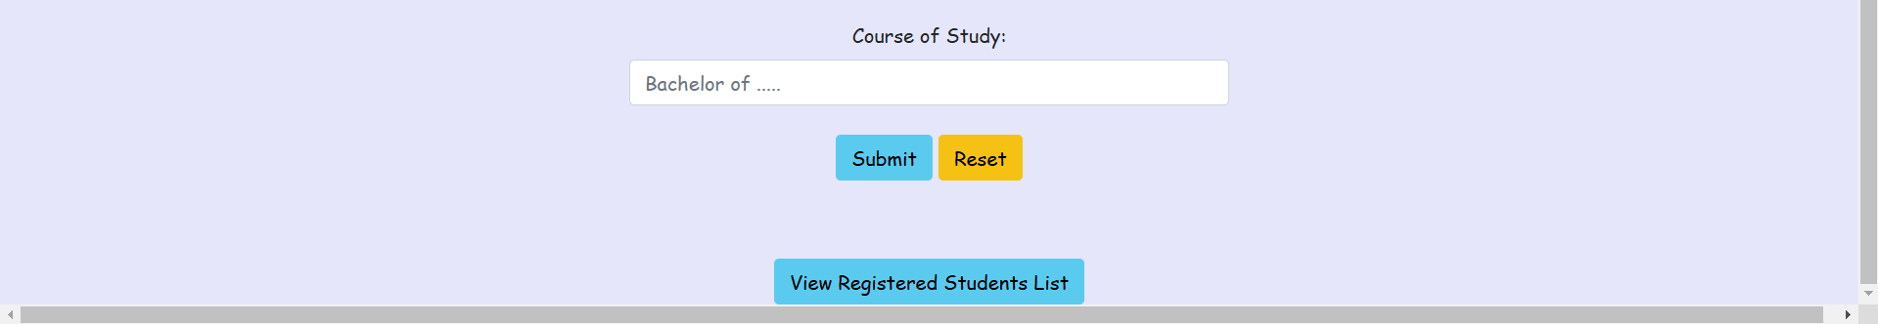

Figure 3 : Interface of Student Registration

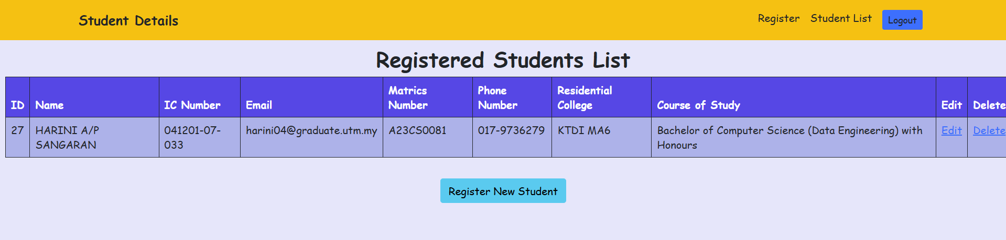

Figure 4 : Interface of Student List

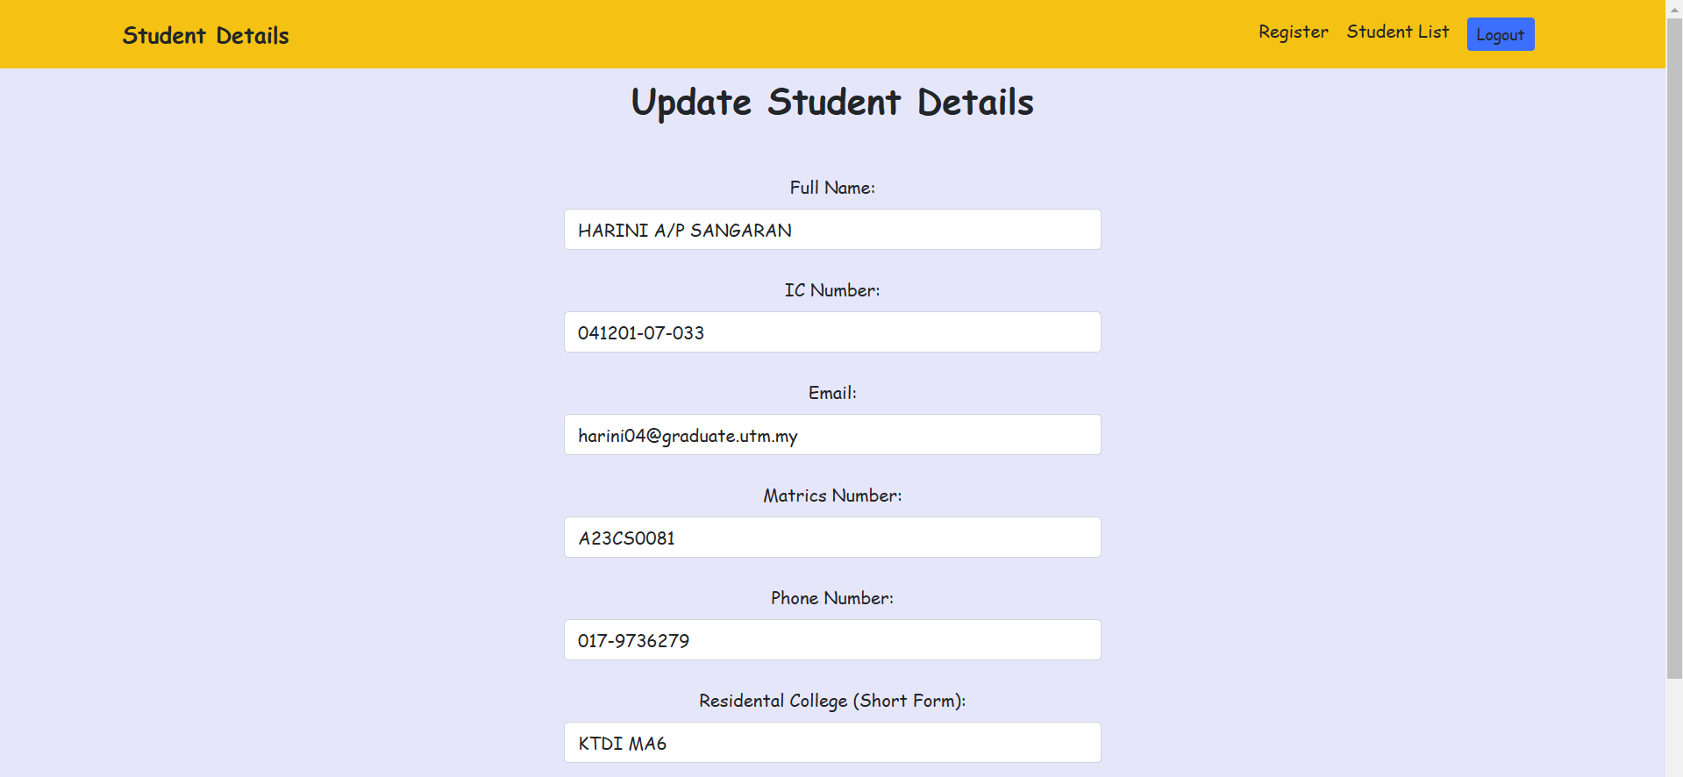

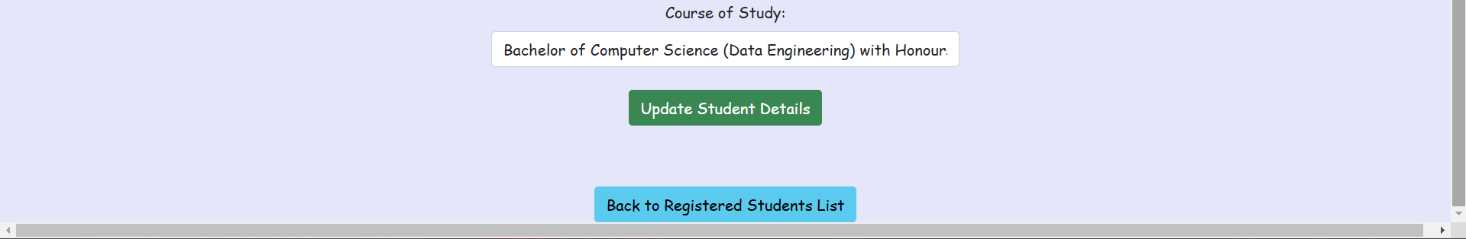

Figure 5 : Interface of Update

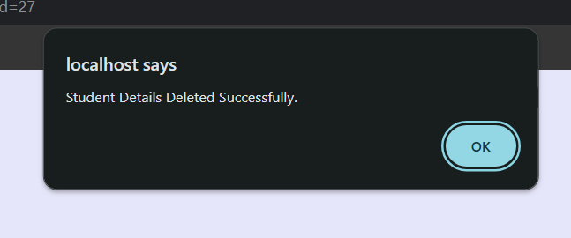

Figure 6 : Interface of Delete

Github link : <https://github.com/harinisangaran/Lab-3-SDT/tree/main/Lab%202_Harini_A23CS0081>